**Comenius University, Bratislava**

**Faculty of Mathematics, Physics and Informatics**

**Wireframes**

Forest Dump

Web design Technology and Methodology

**2018/2019**

**Patrícia Marmanová**

**Dana Škorvánková**

**Michal Brcko**

**Radoslav Hečko**

**Content**

1 Introduction 3

2 Wireframes 4

2.1 Ľubica’s scenario – Desktop application 4

2.2 Joseph’s scenario – Mobile application 4

# 1 Introduction

In this document, we will illustrate two scenarios of two different personas that are using the Forest Dump application. The wireframes of the application will be depicted step by step throughout the whole scenarios.

# Wireframes

In this section, each step of the particular scenario will be visualized and briefly described.

## 2.1 Ľubica’s scenario – Desktop application

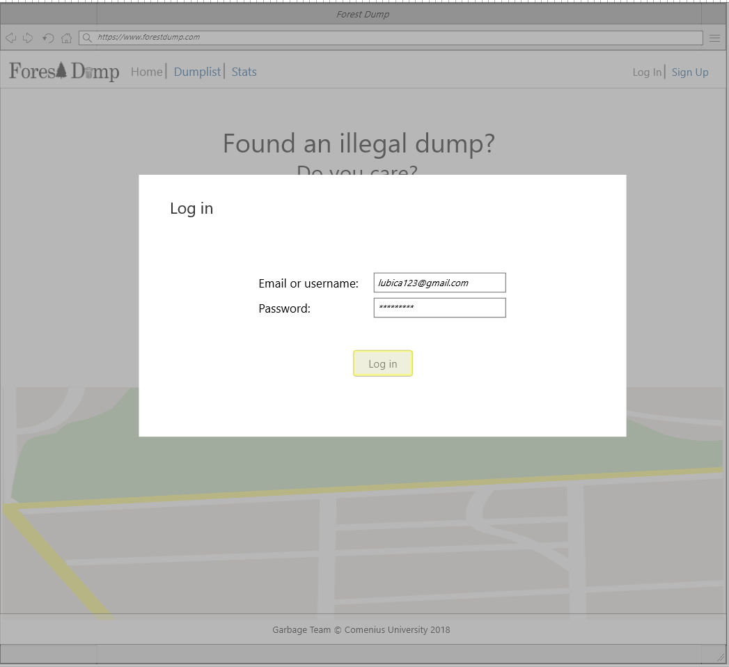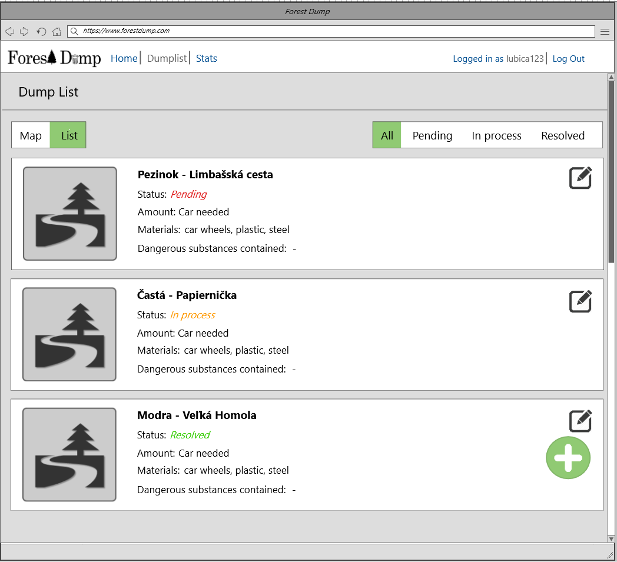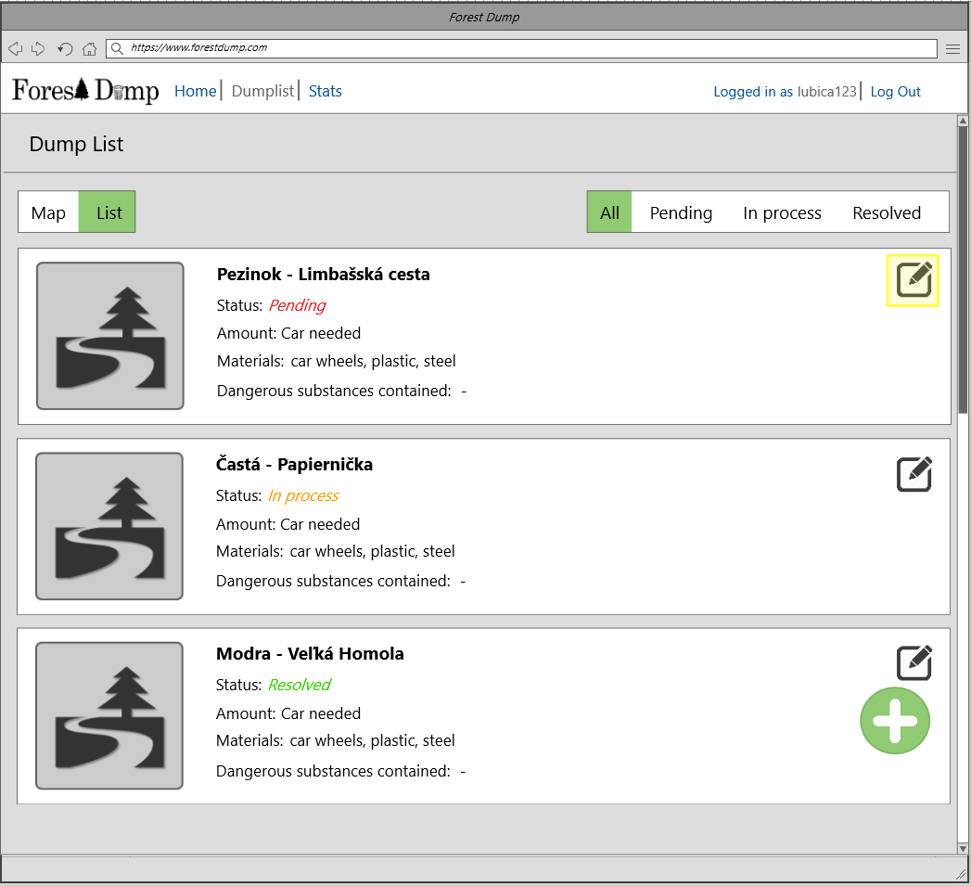

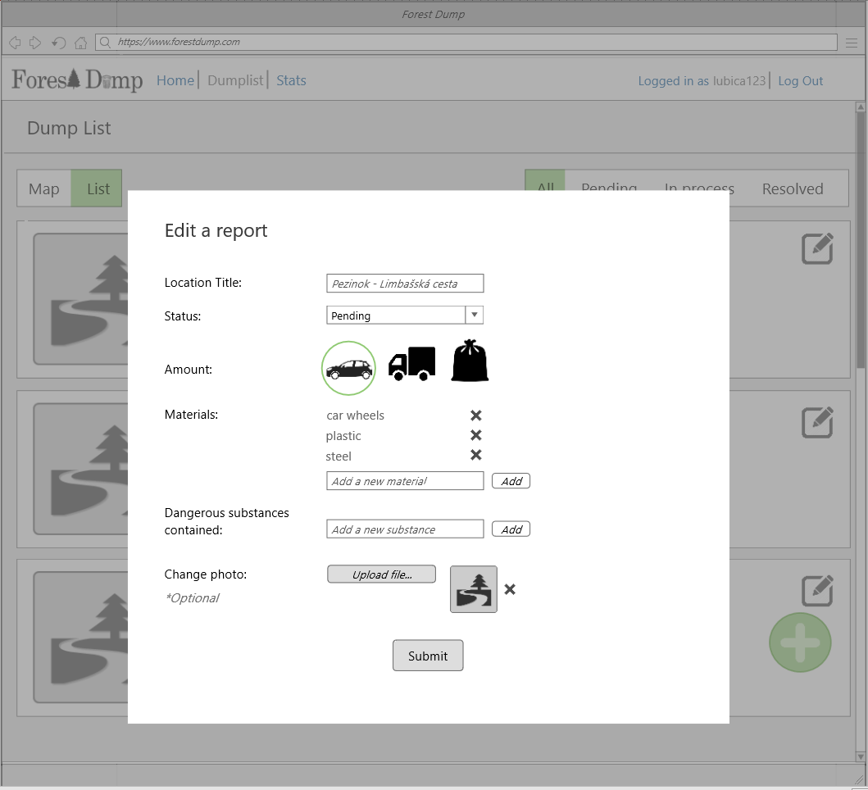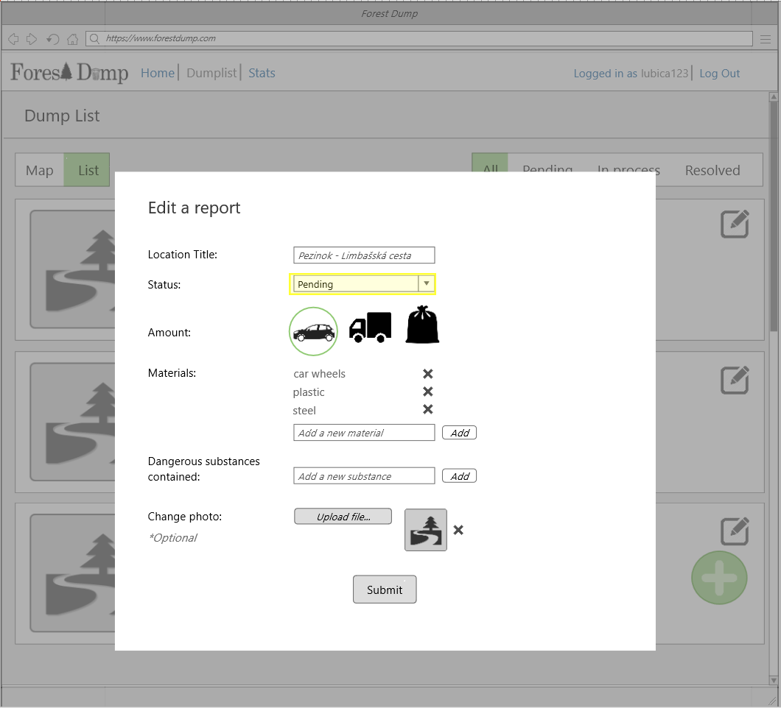

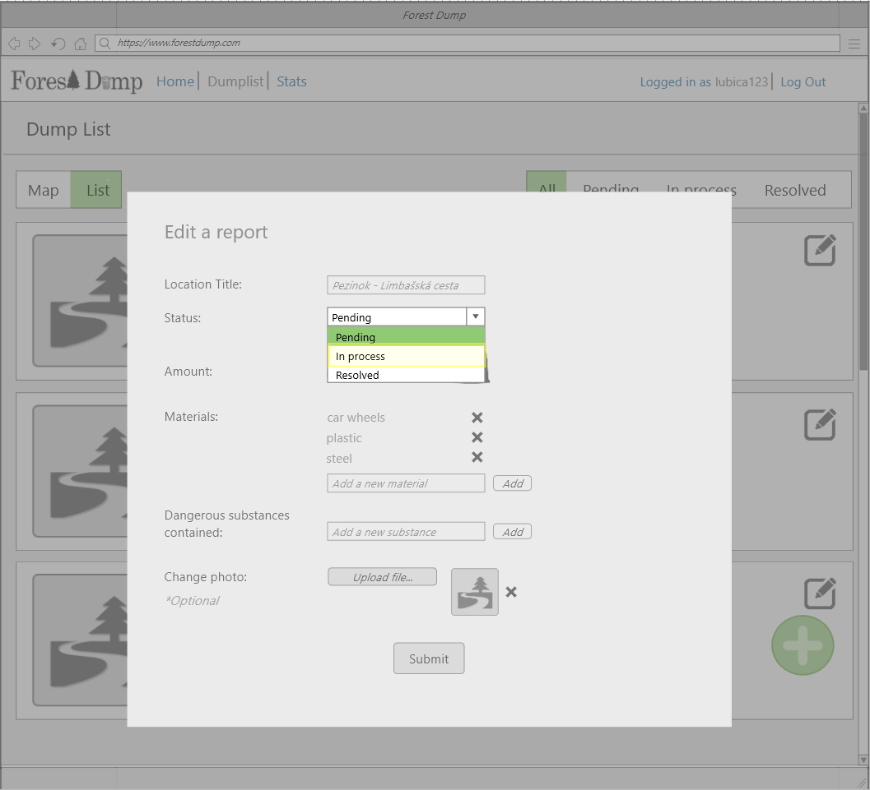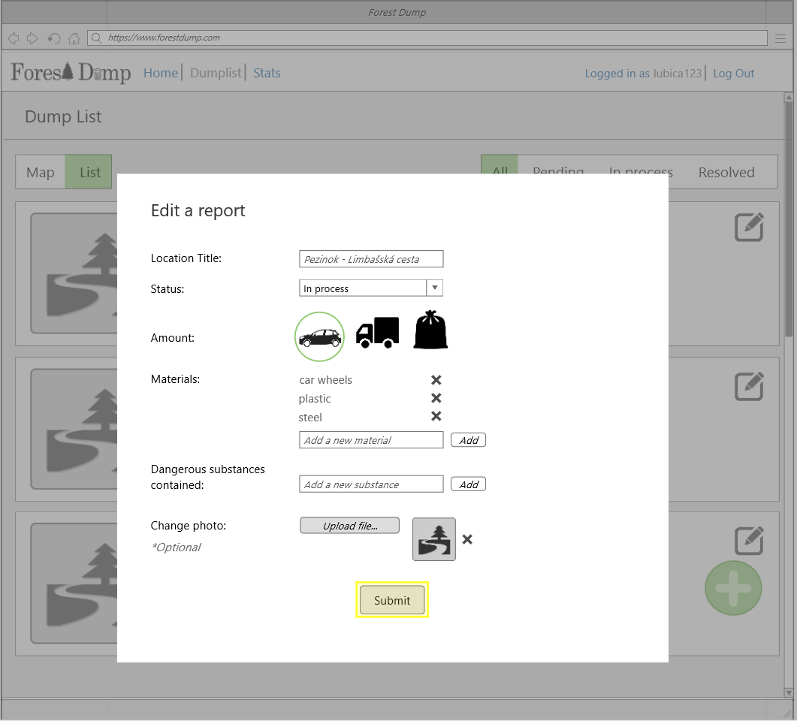

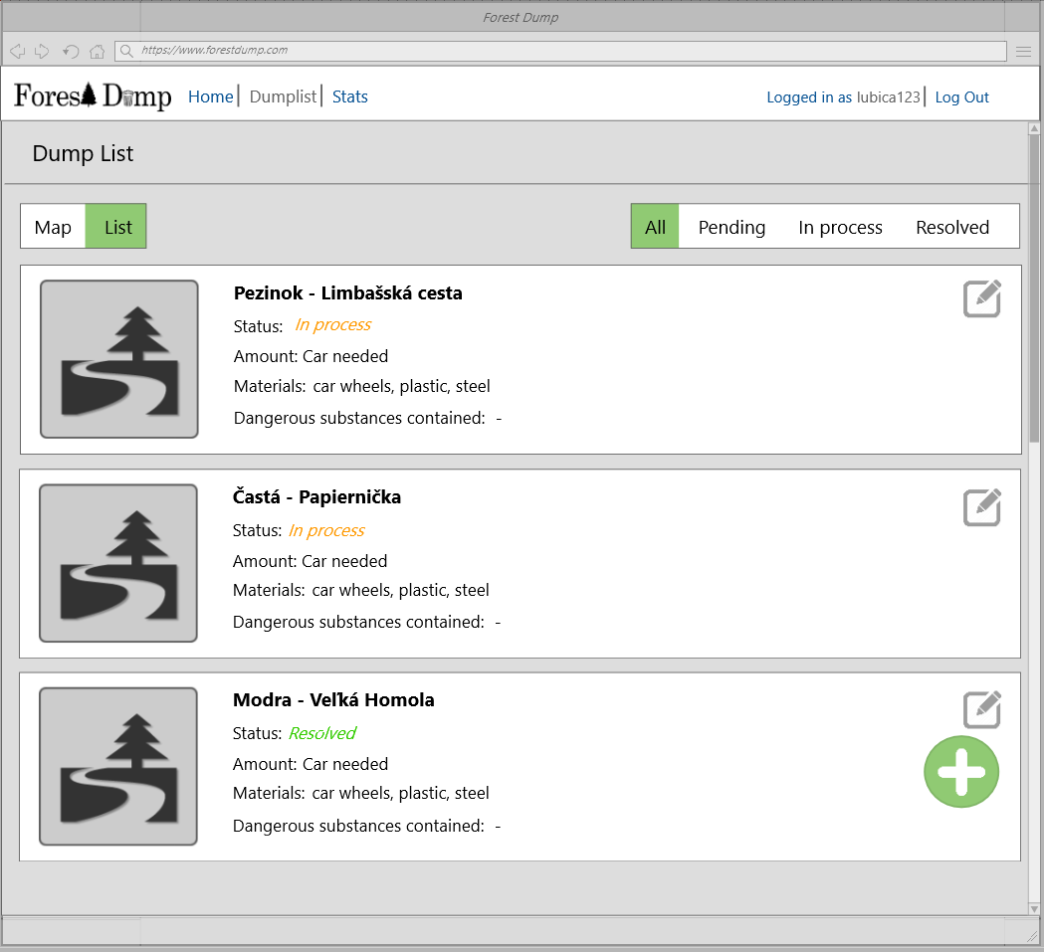

## 2.2 Joseph’s scenario – Mobile application